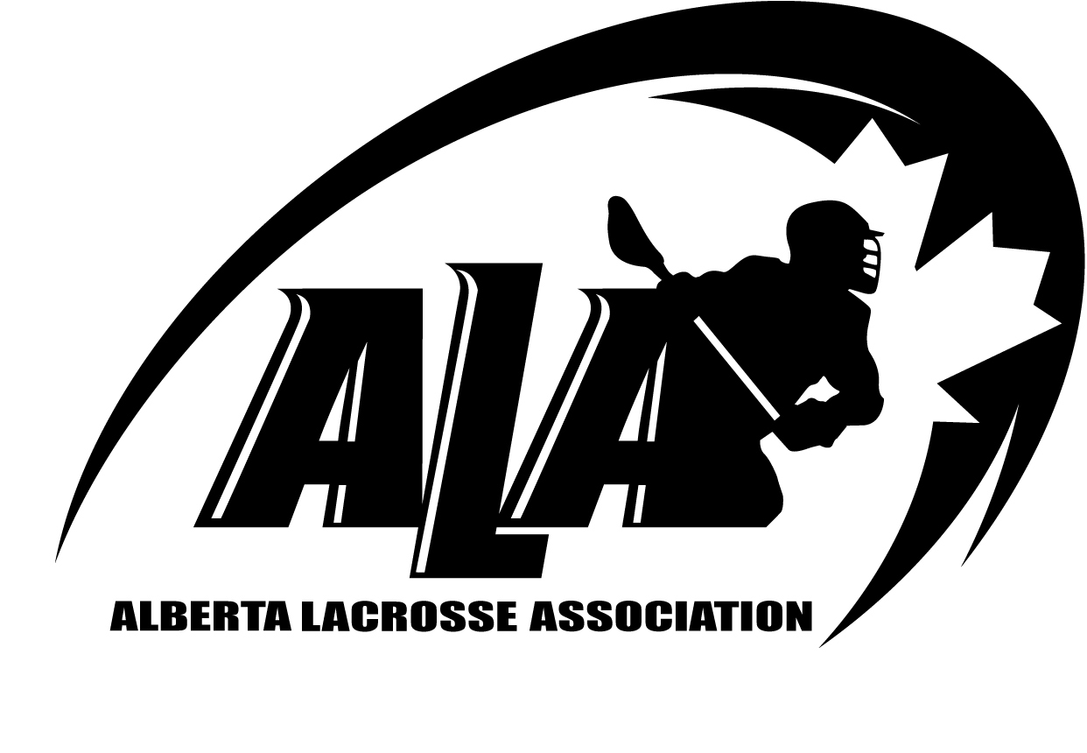
Player Registration Form
Name Last: |  | First | Initial:
«Last_Name» |  | «First_Name» | «Initial»
Street Address: |  | City: | Postal Code:
«Address» |  | «City» | «Postal_Code»
Date of Birth: (dd-mmm-yyyy) |  | Home Phone: | Cell Phone:
«Birth_Date» |  | «Home_Phone»
Club & Level to Play in 2014 |  | Previous Level: | Number Years Played:
 |  | «Level» | «Years_Played»
Sex: |  | Email Address
«Sex» |  | «E_Mail»
Do you wish to Officiate: (circle)  YES NO |  | Aboriginal Decent: (circle)  Status Indian, Non-status Indian, Metis, Inuit, On Reserve,  Off Reserve, N/A
Guardian #1 Last: |  | First:
«Guardian_Last» |  | «Guardian_First»
Home Phone: (If Different) |  |  | Work Phone
«Guardian_Home_Phone» |  |  | «Guardian_Business_Phone»
Street Address: (If Different) |  | City: | Postal Code:
«Address» |  | «City» | «Postal_Code»
Guardian #2 Last: |  | First:
«Guardian_Last1» |  | «Guardian_First1»
Home Phone: (If Different) |  |  | Work Phone:
«Guardian_Home_Phone1» |  |  | «Guardian_Business_Phone1»
Street Address: (If Different) |  | City: | Postal Code:
«Address» |  | «City» | «Postal_Code»

Privacy Policy
See ALA Regulations
Image Waiver
Participants at Provincial and National events, may have their image, likeness, name (excluding personal address, phone, fax number, and/or email address), province, city/town, and club, competitive event, or coaching history used in publications and on the website by ALA as well as its agents and sponsors from time to time. When signing this form, players, volunteers, coaches, officials and, in the case of minors, their parent/guardian, agree that they have the authority to provide this authorization/approval to ALA and its agents, and sanctioned organizing committees. By completing this registration form, I/we acknowledge and agree to the above Alberta Lacrosse Association Waiver and PIPEDA Release,
I allow the use of personal information as outlined above, and image in ALA, and CLA, including newsletter, website, poster, brochure, video, sponsorship packages.

THIS CERTIFICATION MUST BE SIGNED BY A FULLY AUTHORIZED
AND RESPONSIBLE PARENT OR GUARDIAN, IF UNDER 18 YEARS OF AGE

___________________________________________________________________________________ Name (Print) Signature Date

Canadian Anti-Doping Program (CADP)

Canadian Lacrosse Association has adopted the 2009 Canadian Anti-Doping Program (CADP), which is the set of rules that govern doping control in Canada. Administered by the Canadian Centre for Ethics in Sport (CCES), the CADP applies to members of the Canadian Lacrosse Association and participants in Canadian Lacrosse Association sanctioned activities. All members of Canadian Lacrosse Association, whether in the role of athletes or athlete support personnel, are subject to the CADP. By signing below, I acknowledge that I am a member of Canadian Lacrosse Association and I am aware that the CADP applies to me and I consent to its application to me. For further information, please visit the Athlete Zone on the CCES website http://cces.ca/athletezone

PIPEDA

1.0 The personal information you provide to Alberta Lacrosse Association, and different organizing committees for Provincial and National events, is collected under the authority of the PIPEDA privacy bill for Canada. It is used to determine your eligibility for competitive and recreational opportunities, age related events, to facilitate your enrolment, to administer, to provide promotional information and evaluate programs/courses of benefit to players, coaches, Board Members, volunteers and officials, and for insurance and statistical purposes. It may be necessary to disclose this information to the Canadian Lacrosse Association to comply with the requirements of National Sports Federations. In addition, personal information may be, from time to time, submitted to major funding bodies in order to verify registration and meet the funding requirements. This information will be transferred in a safe format.

2.0 Registration information required may include: name, age, birth date, address, gender, emergency contact information in case of accident or illness, position within the club or provincial governing structure, volunteer experience, coaching level attained, officiating level attained, performing and/or competitive level attained and aboriginal decent information. Staff members and senior volunteers may have the following information collected and retained: coaching experience, performance appraisals, resumes and letters of reference, attendance records, coach certification numbers, certifications and equivalencies.

3.0 Your club's Privacy Officer, as well as the Privacy Officer for ALA, are responsible for your personal information, and the personal information concerning any minor children, and they ensure that all personal information is handled in a confidential manner, and all reasonable precautions are taken to avoid loss, theft or unauthorized access, disclosure, copying, use or modification. Any requests to view your personal information should be made in writing to the club or provincial Privacy Officer ALA, Suite 4, 9 Chippewa Rd Sherwood Park AB T9A 6J7

Participants at Provincial, National and ALA sanctioned events, may have their image, likeness, name (excluding personal address, phone, fax number, and/or email address), province, city/town, and club, competitive event, or coaching history used in publications and on the website by ALA as well as its agents and sponsors from time to time. When signing this form, players, volunteers, coaches, officials and, in the case of minors, their parent/guardian, agree that they have the authority to provide this authorization/approval to ALA and its agents, and sanctioned organizing committees. By completing this registration form, I/we acknowledge and agree to the above Alberta Lacrosse Association Waiver and PIPEDA Release,

I allow the use of personal information as outlined above, and image in ALA, and CLA, including newsletter, website, poster, brochure, video, sponsorship packages.

Player Registration |  | Bingo Registration
Registration Fee Amount | $ ____________________ | Club Bingo Date | ___________________
Bingo Credit Amount | $ ____________________
Family Discount Amount | $ ____________________ | $100 Deposit Paid | Cheque / Cash
Registration Amount Paid | $ ____________________
Received By | ____________________ | Received By | ____________________

